I achieved a reliable incremental sync by building a Hybrid SCN-Upsert approach to handle Oracle’s block-level SCN issues.
In simple terms:
- Step 1: Smart filtering
I patched Ora2Pg.pm to fetch only rows from changed blocks using
WHERE ORA_ROWSCN > last_scn.
This reduced unnecessary reads and improved performance.
- Step 2: Safe upsert
Since Oracle tracks changes at the block level, some unchanged rows also came along.
To avoid duplicate key errors, I used
INSERT ... ON CONFLICT DO UPDATE.
- Result
  - New rows get inserted
  - Existing rows get safely updated
  - No duplicate key crashes
  - Incremental sync works reliably
Basically, I filter aggressively, upsert safely, and keep the sync stable.

SCREENSHOTS:
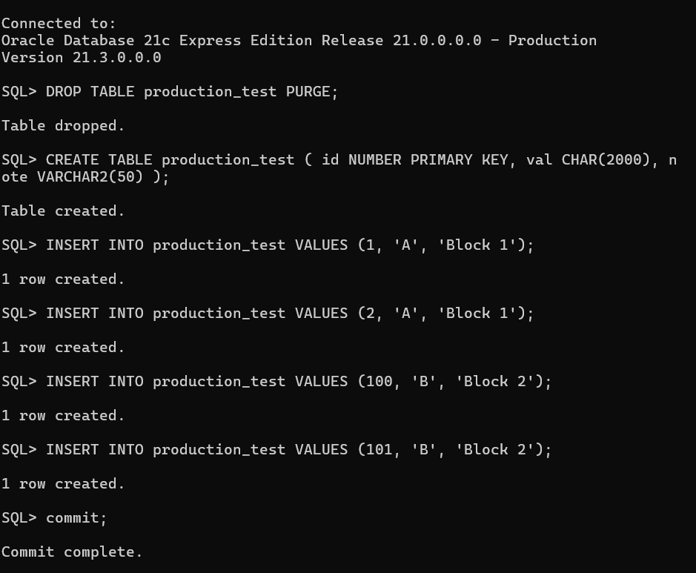

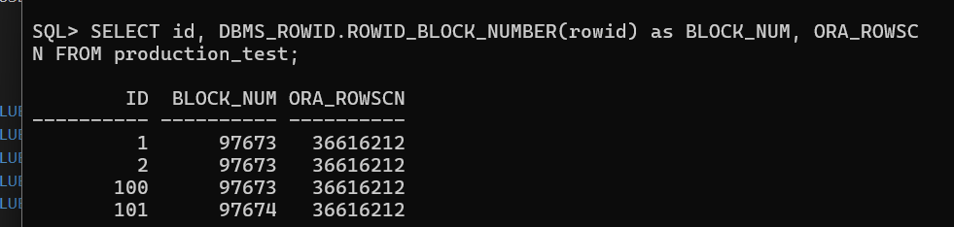
Our db has a bunch of data in it.
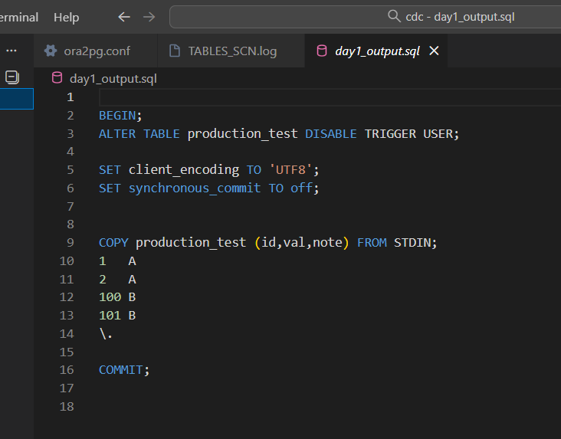
We try to migrate this data using ora2pg, and hence in the output sql, you can see the copy statements for all the data.

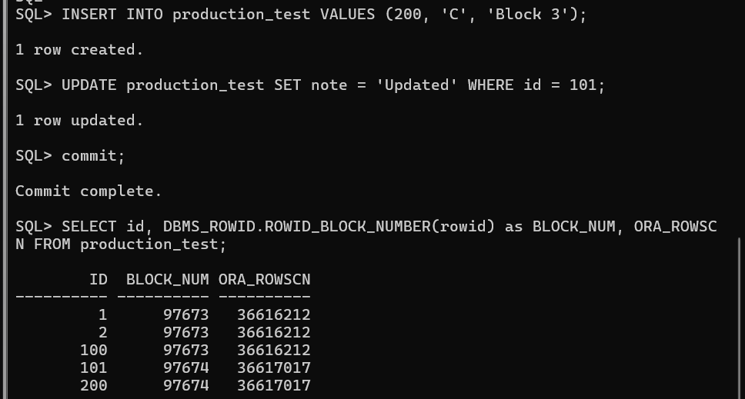But suppose it’s a real world system and hence during the data migration, few changes happened to the data. An update and insertion happened.

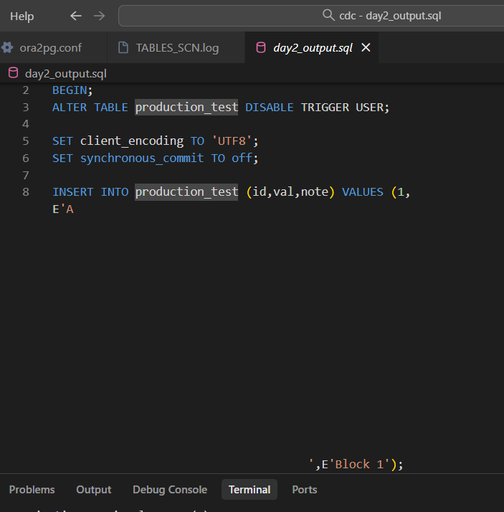

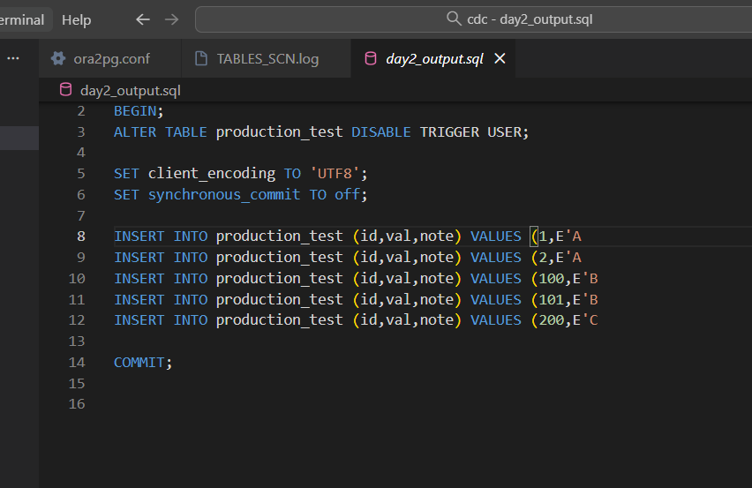

So we try to do the data migration again hoping that in the output sql, only those new changes are observed. But as you can see, again insert statements corresponding to all the data in the db is observed, which is so inefficient.

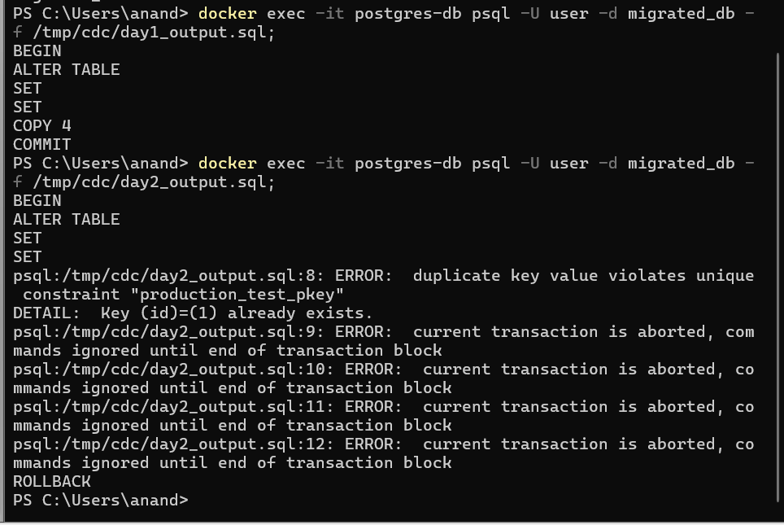

Also, the copy staments corresponding to newly updated rows are obsereved. Which upon running in postgres, will give rise to primary eky unique constraints…

NEW:

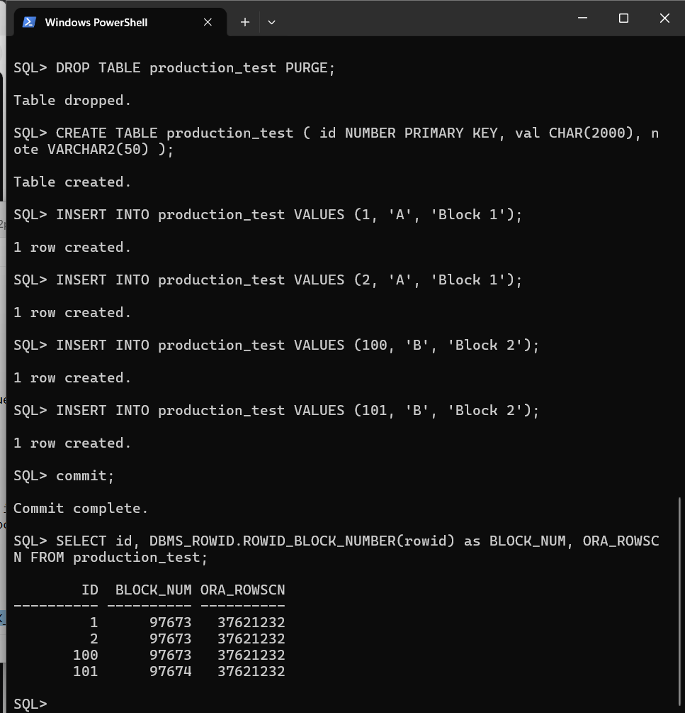

Our db has a bunch of data in it.
We make use of the scn to implement this. Initially thought the data Is spread over different blocks, all are assigned the same scn value.

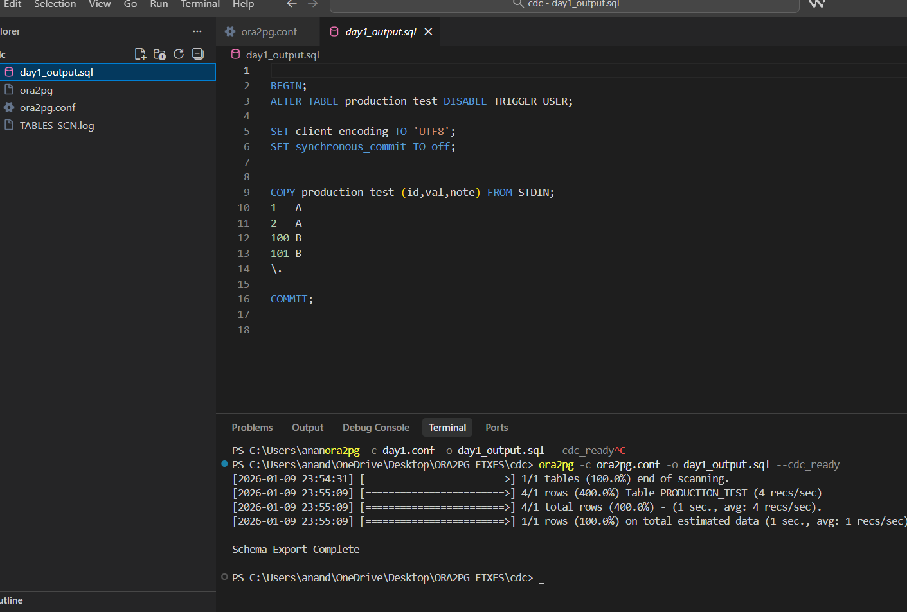
We try to migrate this data using ora2pg, and hence in the output sql, you can see the copy statements for all the data.

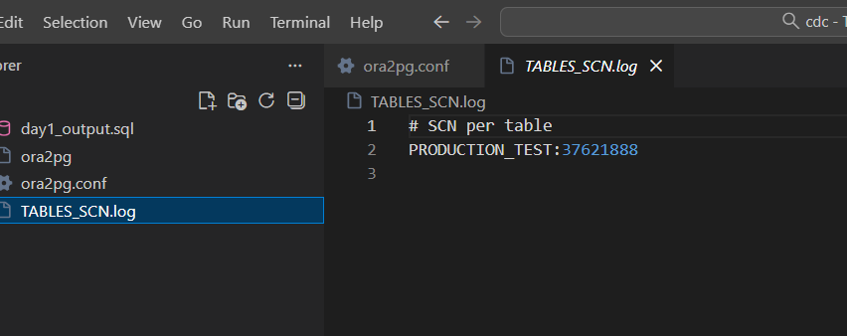
Also a higher scn is recorded in a log file.

But suppose it’s a real world system and hence during the data migration, few changes happened to the data. An update and insertion happened. The newly added/updated block of rows will be assigened a higher scn than that recorded in the log file.. the untouched blocks will retain its lower scn value.

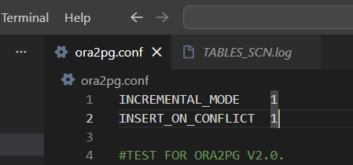

To activate my new feature, set these to 1 in the config file.

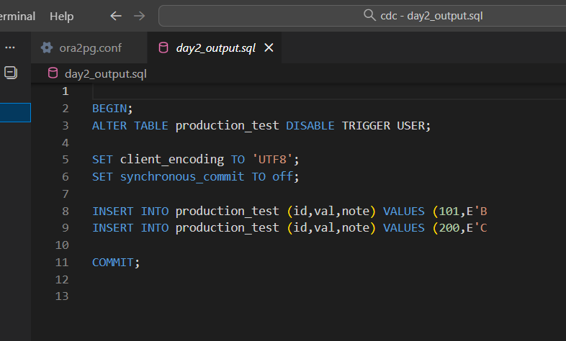
Now, insert staments are generated only for those new updated/inserted rows.. hence its efficeneient.
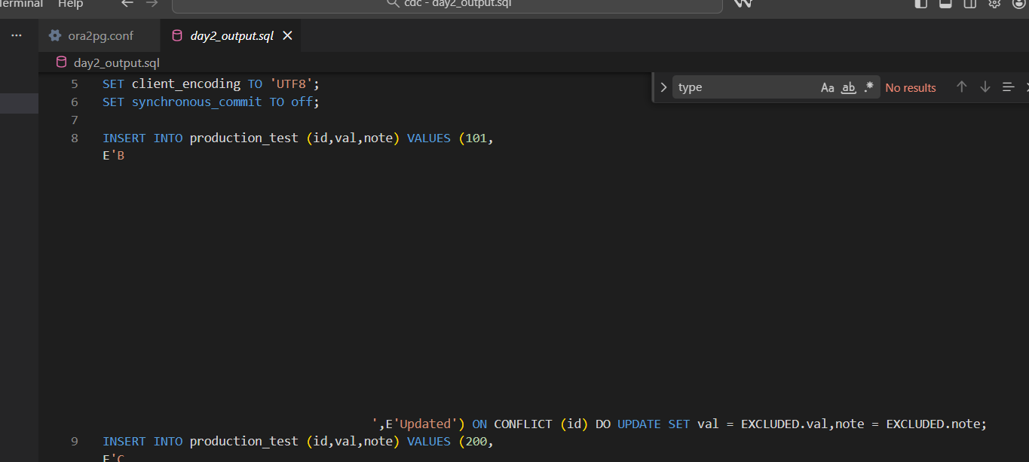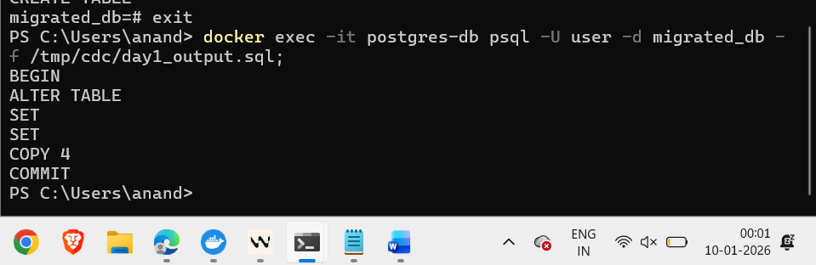
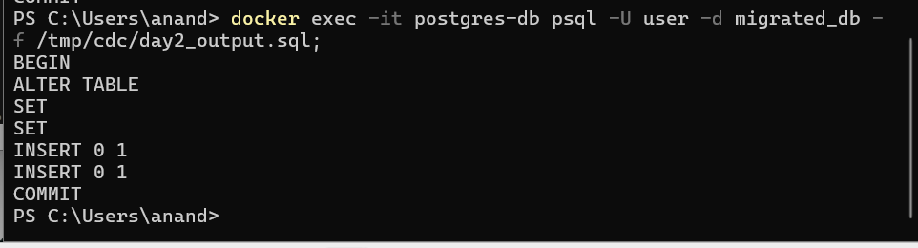

No primary key constraint errors!!

